**Sunkari Manohar**

**Assessment 3 – 11/01/2024**

**Azure Devops**

**Creating a sample YAML pipeline**

Step-1: Open the Azure DevOps page.

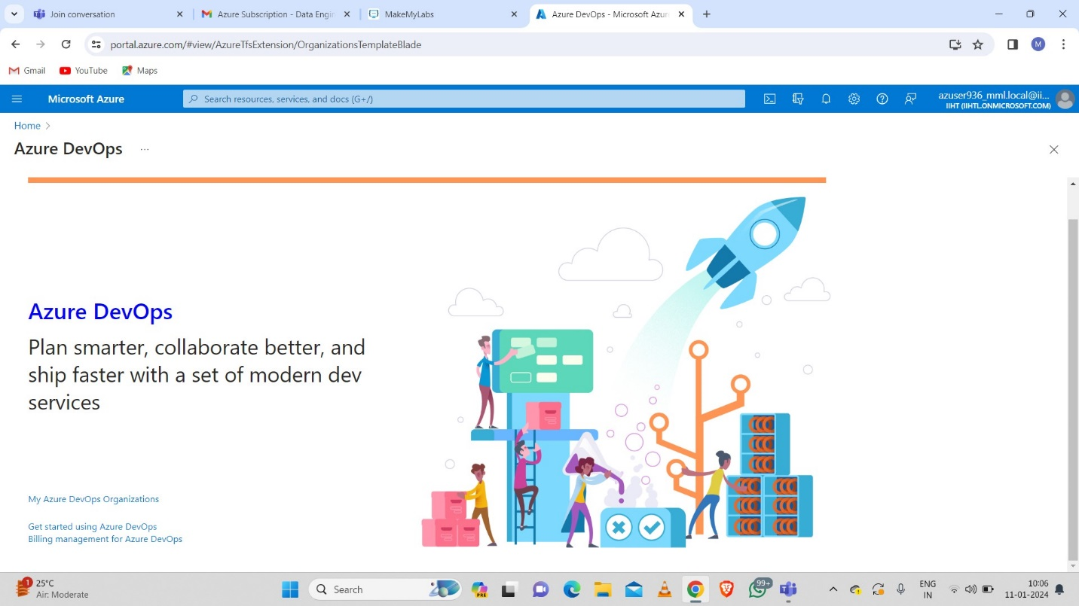

Step-2: Create a new organization.

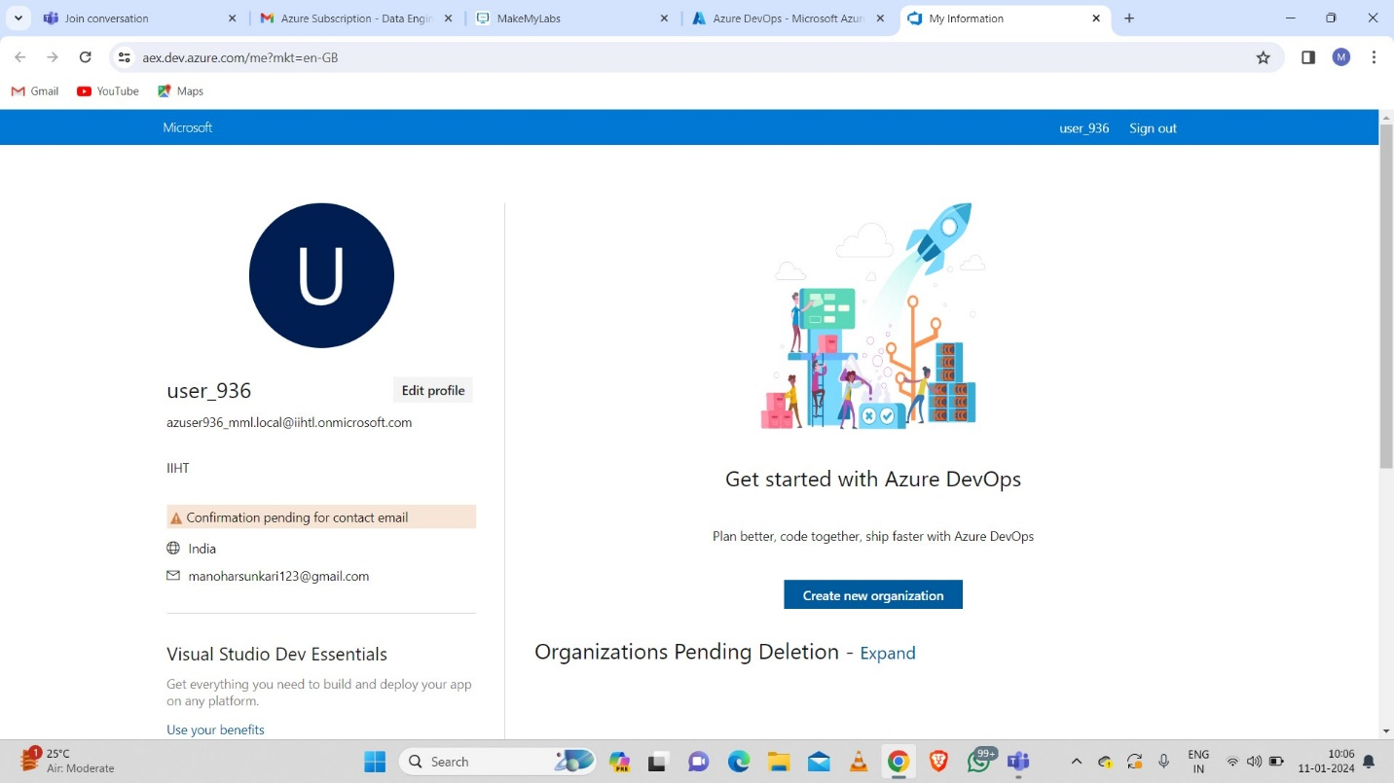

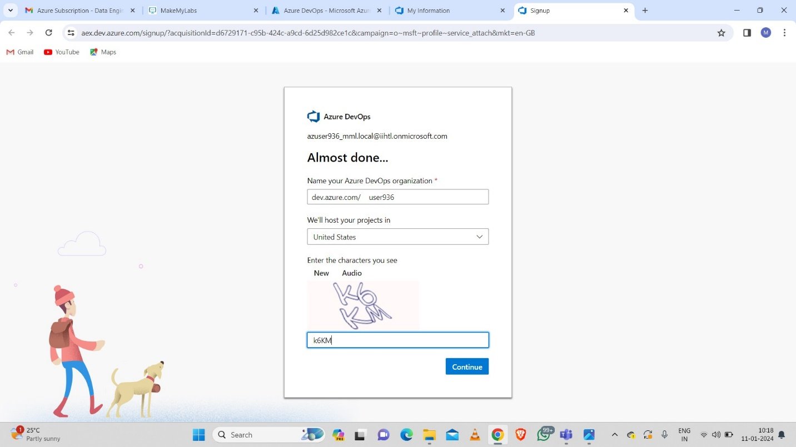

Step-3: Create a project.

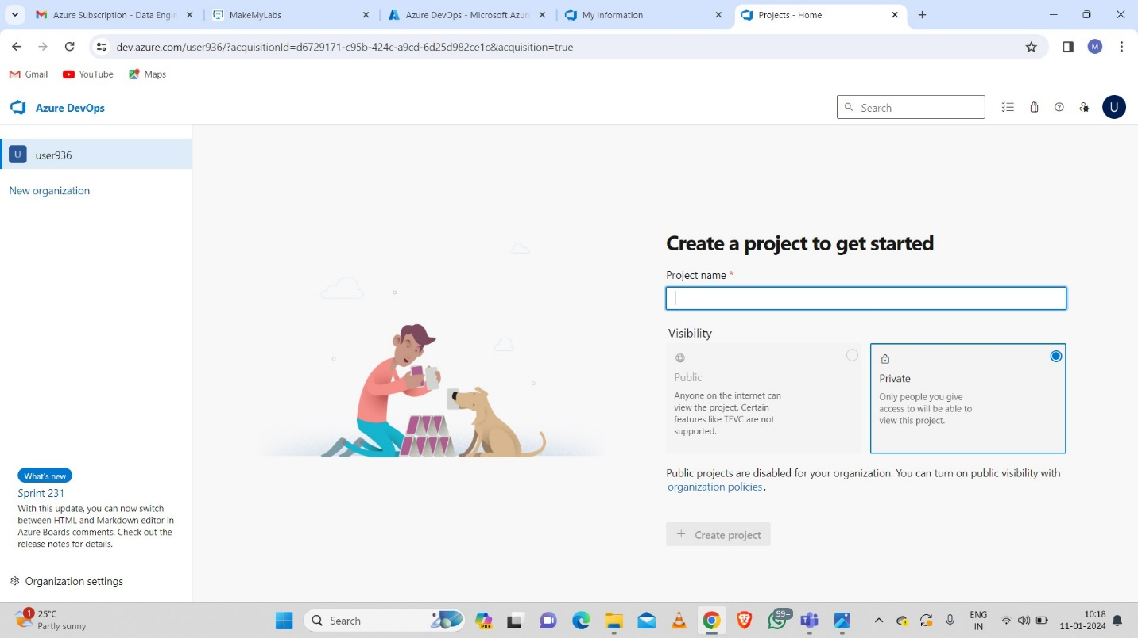

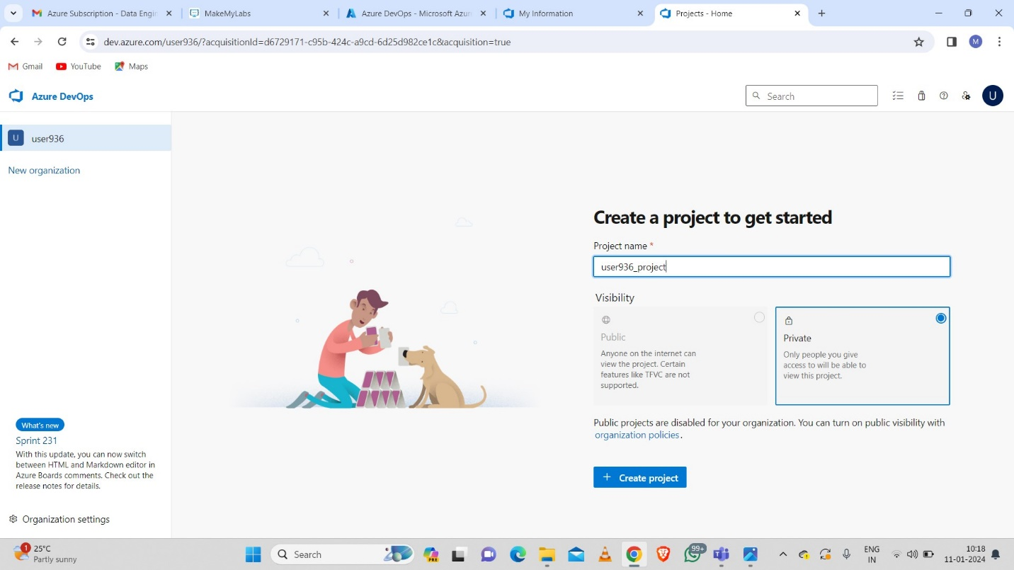

Step-4: Create a repository.

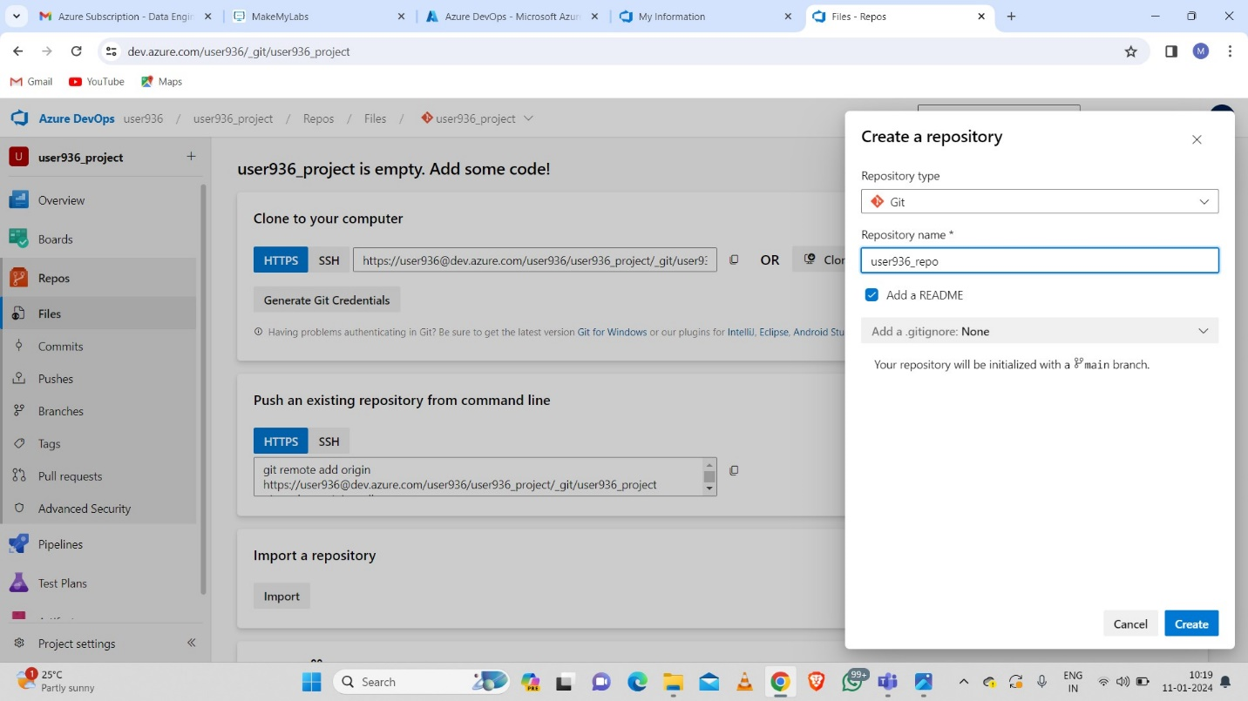

Step-5: Create a new pipeline.

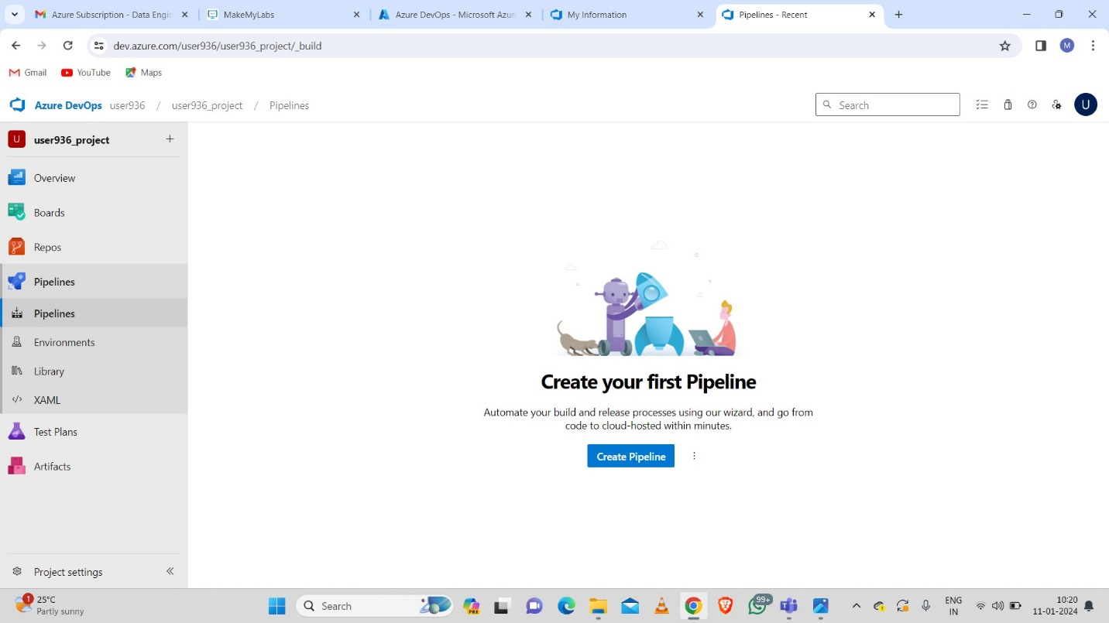

Step-6: Select your code as in Azure Repos Git.

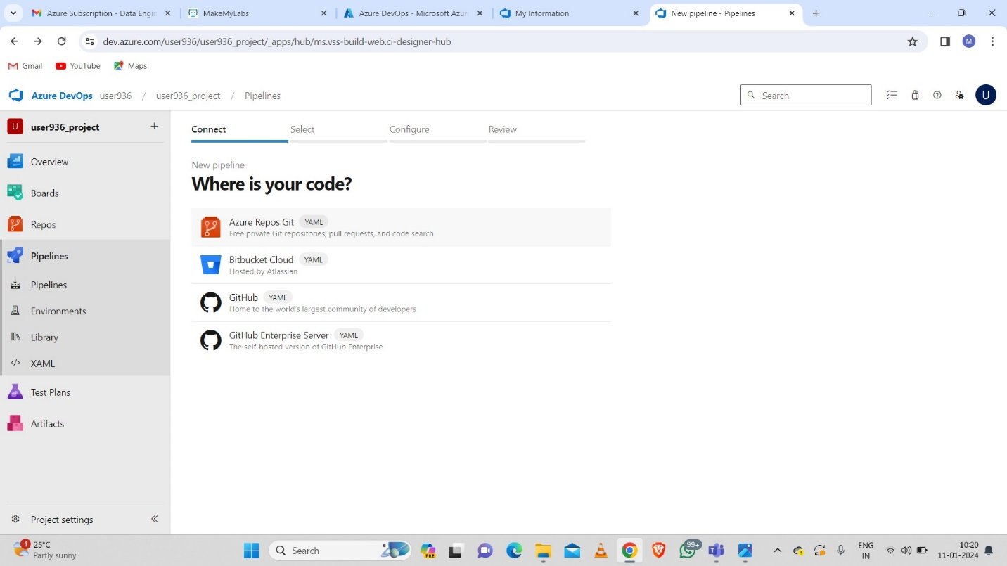

Step-7: Select the repository to link with the pipeline.

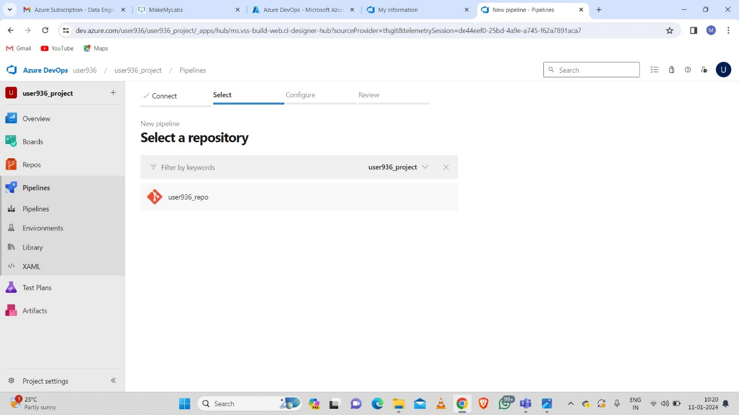

Step-8: Configure your pipeline by clicking on Starter pipeline.

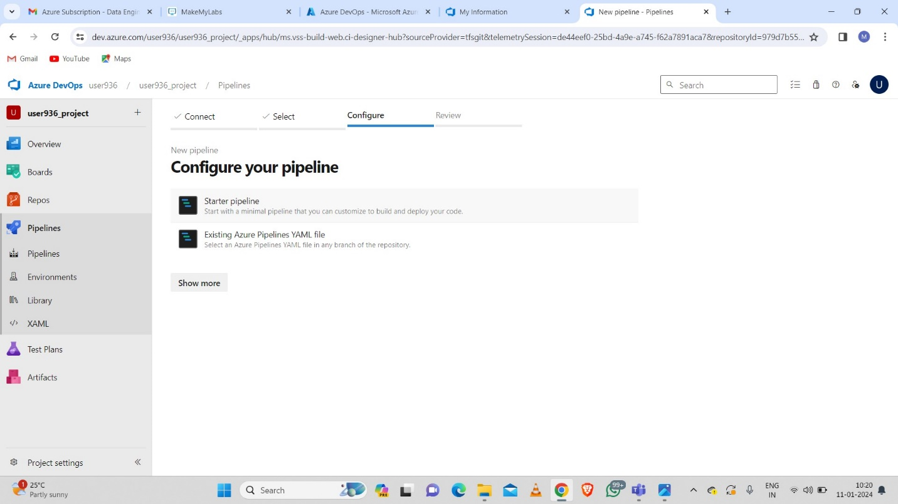

Step-9: Click on save and run.

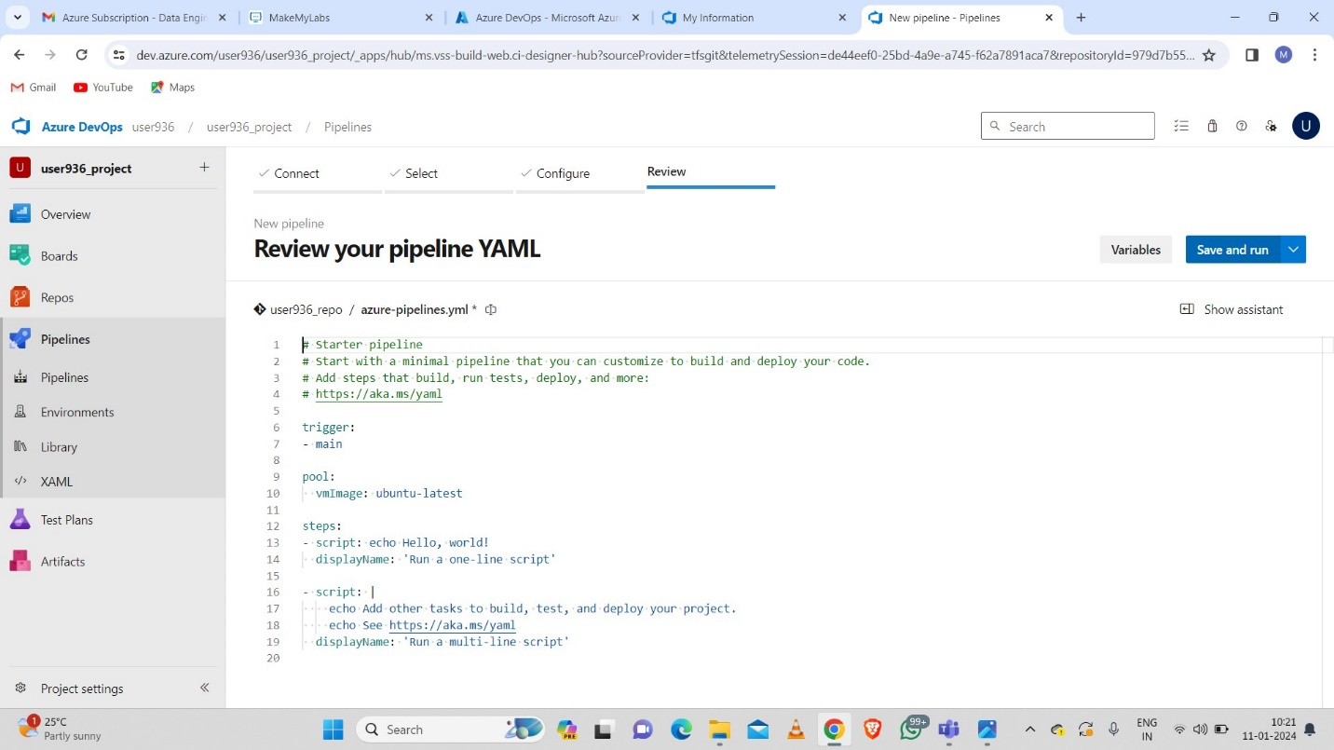

Step-10: Commit the message and click on save and run.

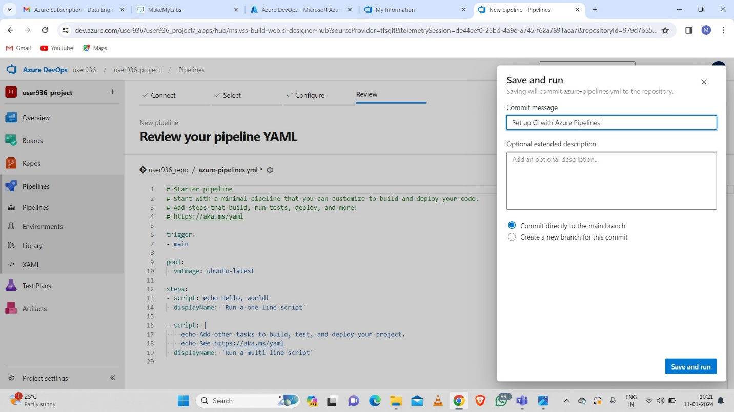

Step-11: We can see YAML pipeline is creating.

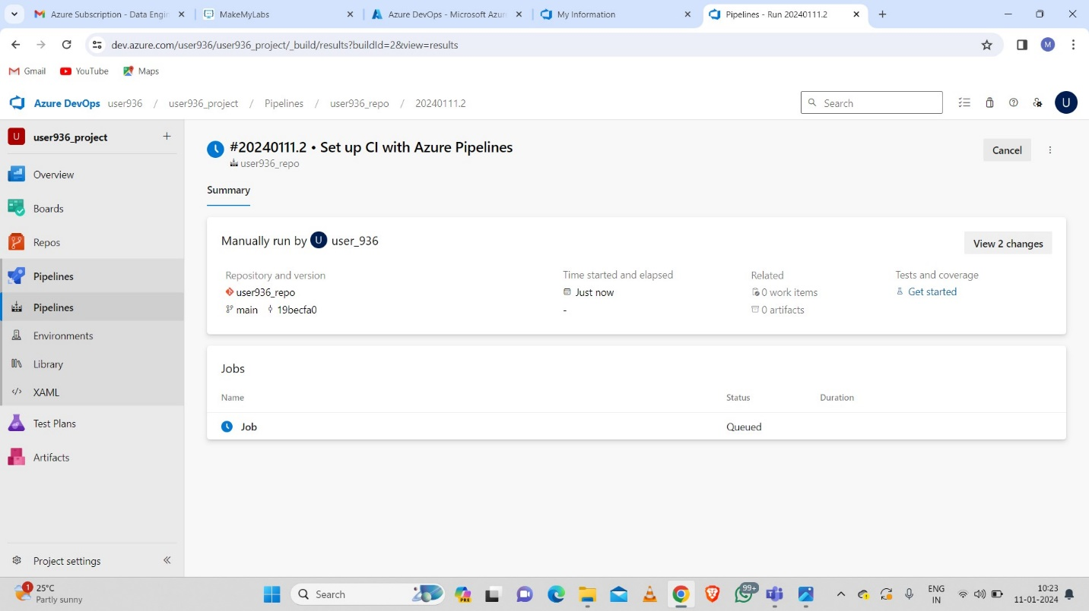

Step-12: Delete the organization.

